Steps for Preparation of Rs.10.00 lakh Action Plan for KPS
- From www.schooleducation.kar.nic.in, go to Karnataka public school website.
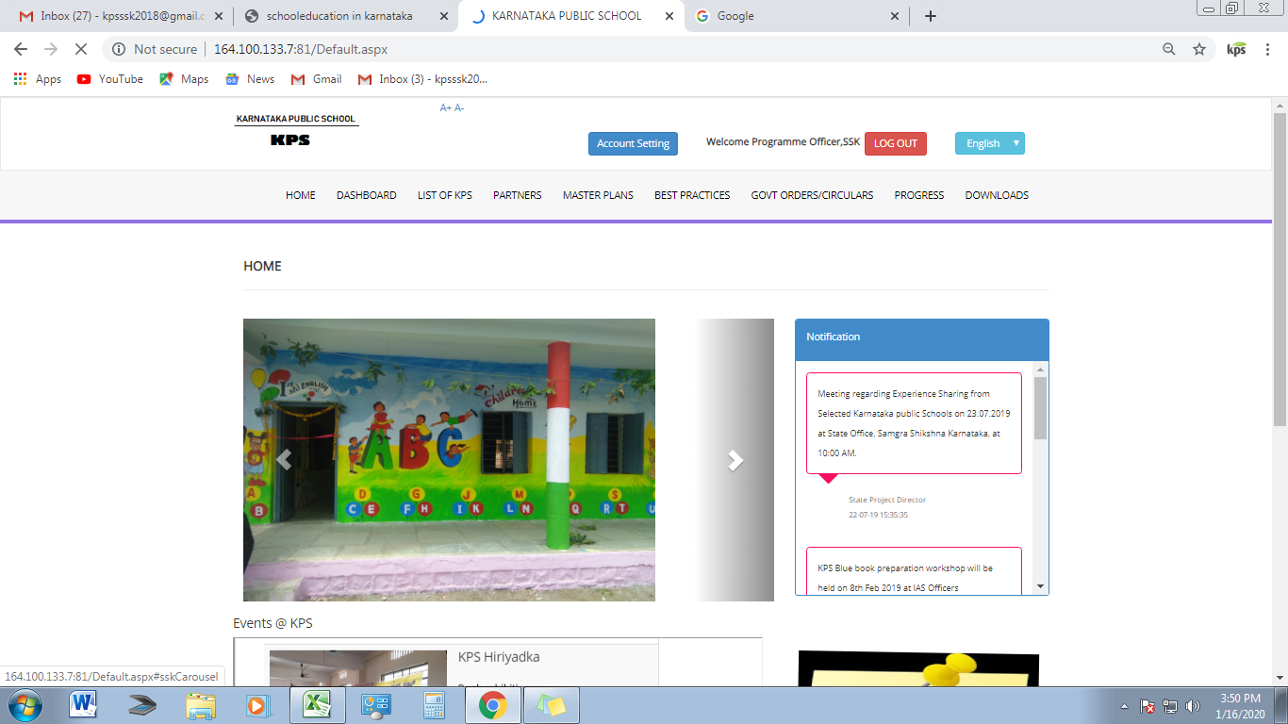

- Go to ‘Progress’ Sub heading, the following drop down will get listed.
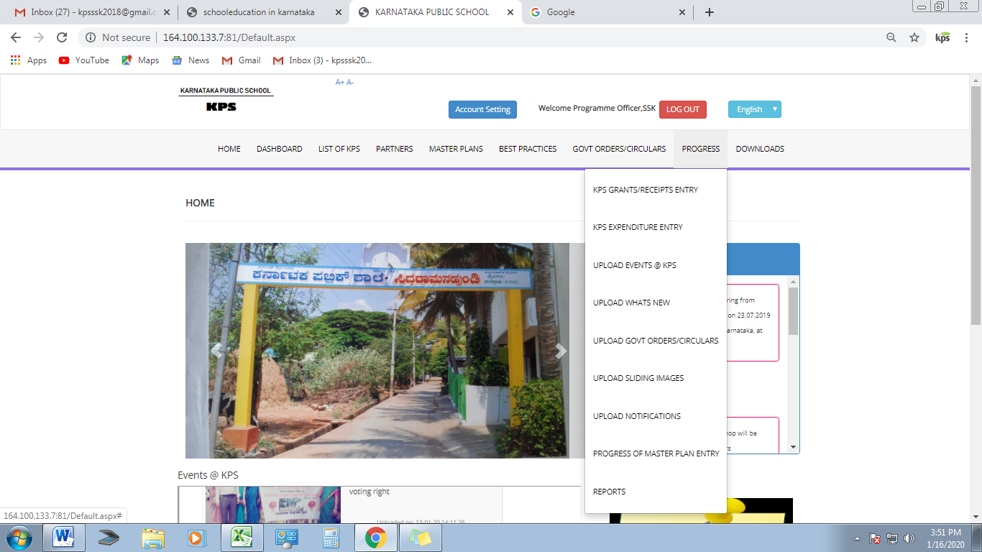

- Click on ‘Reports’, the following screen will appear.
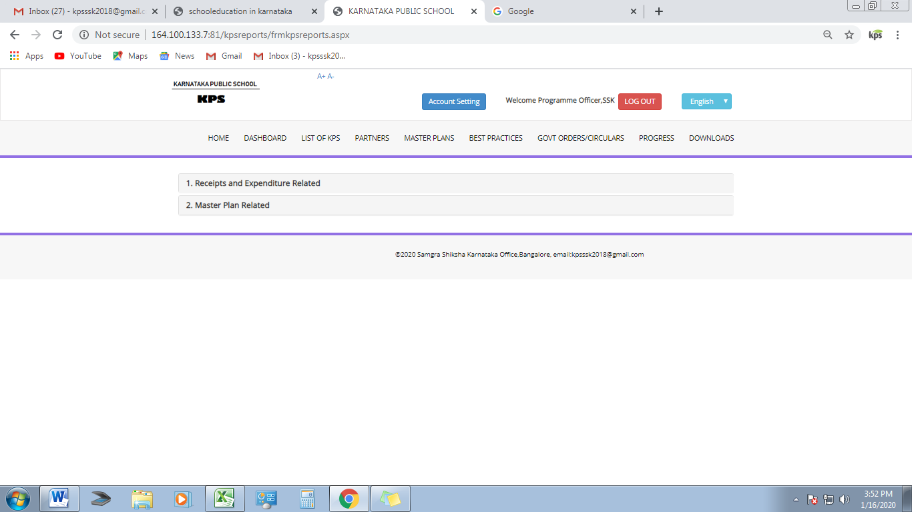

- Click on ‘Master Plan related’ Head. The following screen appears.
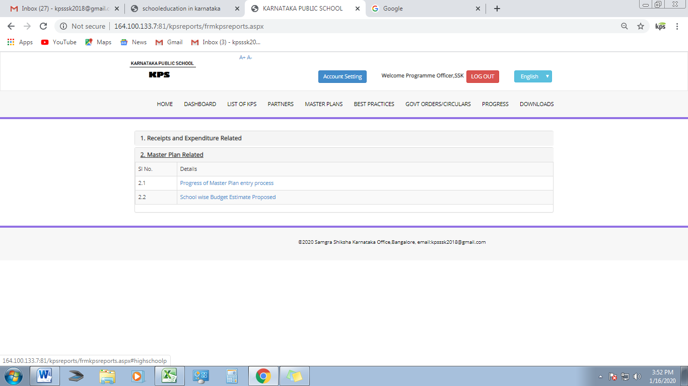

- Select ‘School wise Budget Estimate Proposed’. The following screen appears.
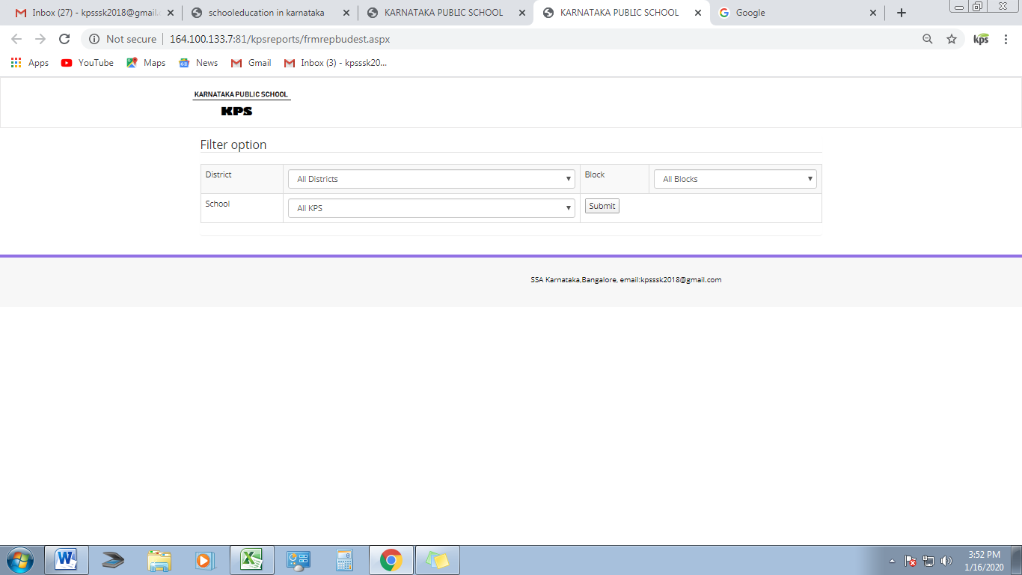

- Select from drop down, the District, Block and your school. The total Budget proposed screen will appear as follows:
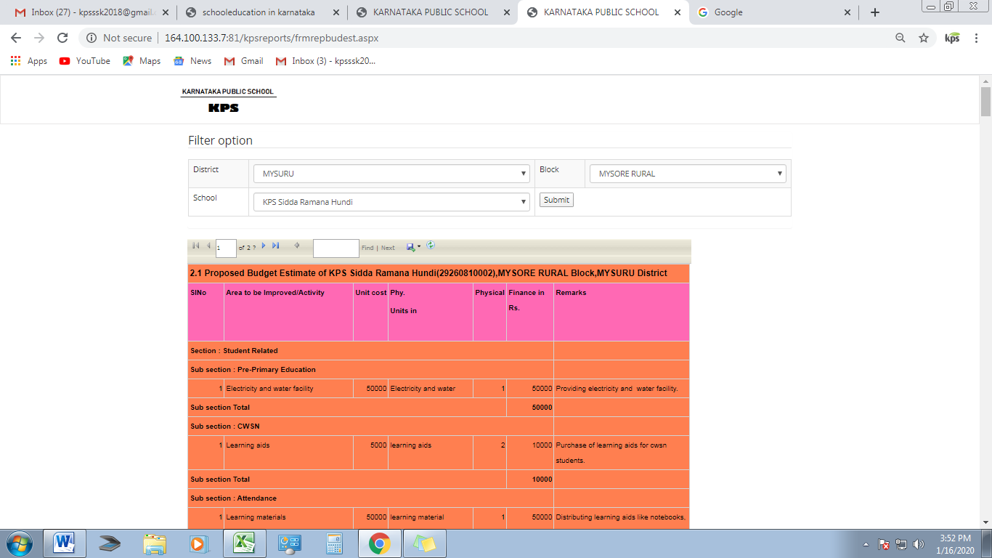
- Above the Proposed estimated Budget sheet, an option for exporting the sheet to excel is given, which is next to ‘Find/Next’. An option of ‘Export’ appears as per below screen.
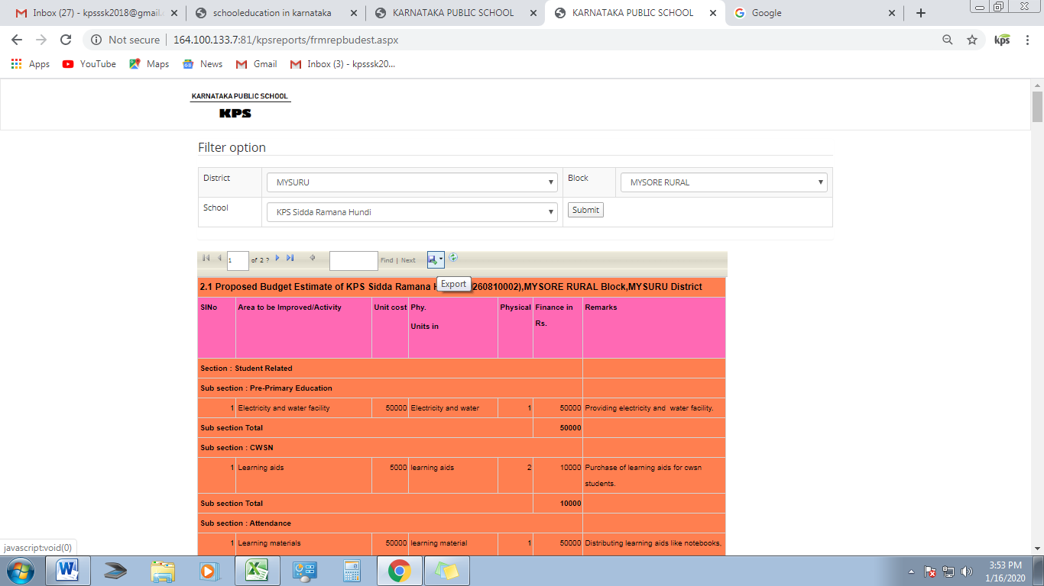
- As you click on export, the following three option to convert the sheet appears: Excel, PDF and Word, Select ‘Excel’ the sheet gets downloaded in excel format.
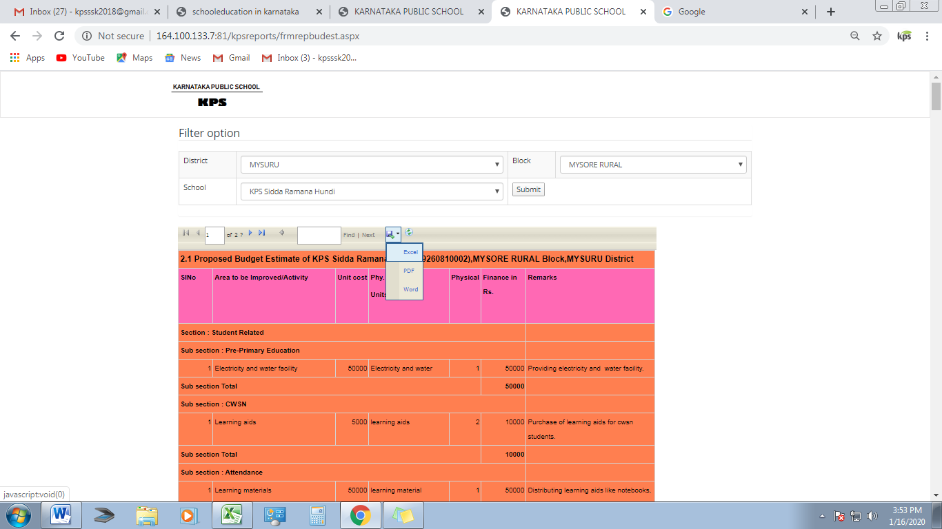

- The Excel sheet as below appears,

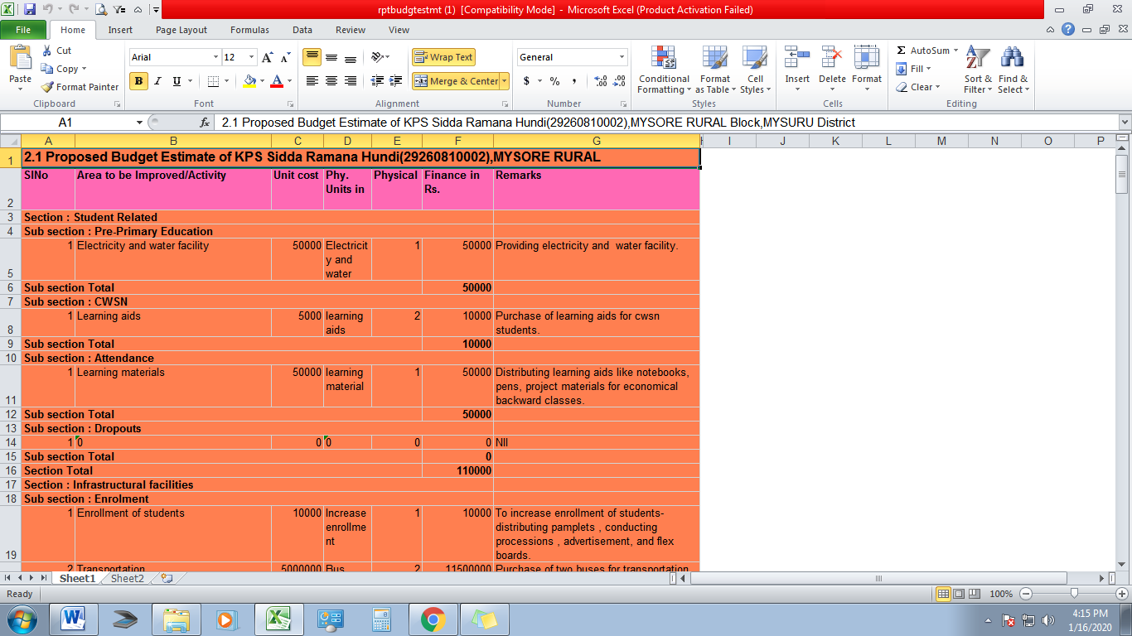

- In the next step de-colorize the sheet and as per local need and priority make plan for Rs.10.00 lakhs.

- Once finalized, send the Soft copy (kpsssk2018@gmail.com) and Signed hard copy to the State Office, Banglore.

